Faysal Khatri

CSC220 -- Activity 5

2017-06-18

# Part 1

1. Three steps:  
   1. Compilation - Translate source code to assembly code which the system’s CPU can use.  
   2. Assembly – Translate assembly code to machine language  
   3. Linking – Connects machine code for a program to other programs or libraries.
2. Version 4.8.4 of gcc, as reported by gcc --version

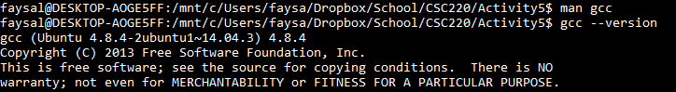

# Part 2 (#3)

## Sample Output

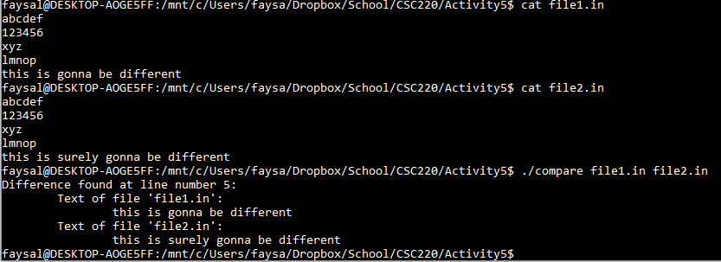

## compare.c

#include<stdio.h>

#include<stdlib.h>

#include<string.h>

#define SIZE 100

/*

*chomp makes sure there is a null terminator at the end of each line

*/

void chomp(char * ptr) {

while(*ptr != '\n') {

ptr++;

}

*ptr='\0';

}

int main(int argc, char *argv[]) {

FILE *infile1, *infile2;

char buffer1[SIZE];

char buffer2[SIZE];

int i = 1;

infile1 = fopen(argv[1], "r");

infile2 = fopen(argv[2], "r");

int f1 = fgets(buffer1, SIZE, infile1);

int f2 = fgets(buffer2, SIZE, infile2);

while ( f1 || f2 ) {

chomp(buffer1);

chomp(buffer2);

if (strncmp(buffer1, buffer2, SIZE) != 0) {

printf("Difference found at line number %d:\n", i);

printf("\tText of file '%s':\n\t\t%s\n", argv[1], buffer1);

printf("\tText of file '%s':\n\t\t%s\n", argv[2], buffer2);

break;

}

f1 = fgets(buffer1, SIZE, infile1);

f2 = fgets(buffer2, SIZE, infile2);

i++;

}

fclose(infile1);

fclose(infile2);

return 0;

}